AP CHEMISTRY CHAPTER 6: ELECTRONIC STRUCTURE OF ATOMS (Pgs. 214-223 and 234-255)
EQ: _______________________________________________________________________________________________
Questions:
Electronic Structure-2
Electronic structure is ______________________________________________________________

What is one way that the properties of extremely small particles are explained? :_______________
Waves-3-4
Label the wavelength, crest/peak, trough:

The wavelength (λ) is the ________________________________________________________.
Frequency (ν)is the ____________________________________________________________.

The longer the wavelength, the ______________ the frequency.

Electromagnetic Radiation-5  All __________________________ travels at the same _____________.  The speed of light is: __________________  Equation for speed of light: | 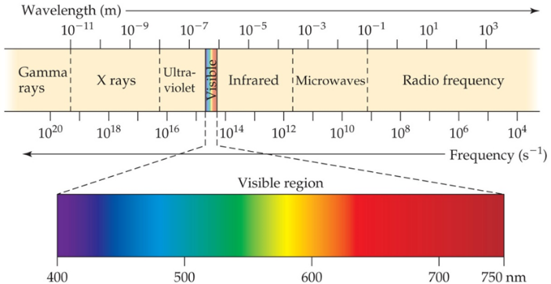
The Nature of Energy—Quanta-6-7
What cannot be explained by the wave nature of light? ____________________________________
____________________ explained it by assuming that energy comes in ______________ called ___________ (singular:__________)
The Photoelectric Effect-8
The photoelectric effect was explained by ______________________ using ______________.
Each metal has a different _____________ at which it _____________ electrons. At a ____________ energy, electrons are not emitted.
What did Einstein conclude?

E=

h is _____________ constant, and equals __________________________.
Continuous vs. Line Spectra-10  What is NOT observed for atoms and molecules? __________________________  Where does one see this? ______________  Each element has a unique _______________  Which is made up of ____________ wavelengths. | 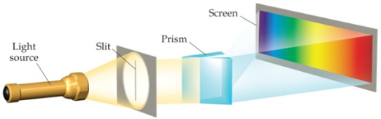  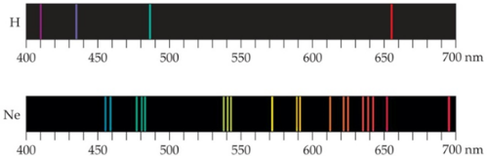  Label Each:
The Hydrogen Spectrum-11
______________________ ( ) discovered a formula relating the _____________ to integers.
_____________________ advanced this formula.

Formula: _________________ explained why this mathematical relationship works.
The Bohr Model-12  ____________________ adopted Planck’s assumption and explained these phenomena: | The Bohr Model-13
The Bohr Model-14  What is the equation for calculating the energy absorbed or emitted from the process of electron promotion or demotion?:  R_{h}=  n_{i} and n_{f} are the _________________________ | Limitations of the Bohr Model-15  What are three limitations of the Bohr model?
Important Ideas from the Bohr Model-16  What parts were incorporated into the current atomic model? | Energies of Orbitals—Hydrogen-32  For a one-electron ______________ atom, orbitals on the same energy level have the same ___________. These are called ______________ orbitals.
Energies of Orbitals-Many-electron Atoms-33  _______________ between electrons increases as the number of ____________ increases.  All orbitals on the same energy level are degenerate in multi-electron atoms. T or F ?  Orbital sets in the same ______________ are _______________.  What happens to energy levels? | Spin Quantum Number, m_{s}-34  In 1920, what was discovered about two electrons in the same orbital?:  The _________ describes its _______________, which affects its ______________.  This led to _______________________________.  What are the vales of the spin quantum number:
Pauli Exclusion Principle-35
- No two electrons in the same atom can have ____________________________.
- No two electrons in the same atom can have identical _____________________.
- Every electron in an atom must differ by at least ________ of the four quantum #’s.
Electron Configurations-36-38
Electron configuration is the way _______________________________________________.
The most stable organization is the lowest possible energy, called ______________________.

Each component consists of :
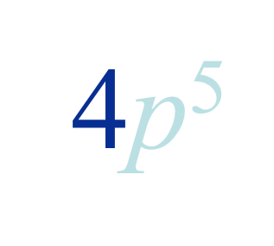
- A number denoting __________________________________________.
- A letter denoting the _________________________________________.
- A superscript denoting _______________________________________.

Draw a line to each corresponding part of the picture from its correct definition.
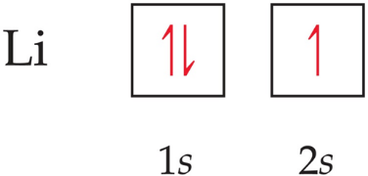
Orbital Diagrams-39
What does each box in the diagram represent? ____________________
Half arrows represent? ______________
The direction of the arrow represents what? ______________________
Hund’s Rule-40
“For degenerate orbitals, the lowest energy is attained when the number of electrons with the same spin is maximized.”

What does this mean?

Condensed Electron Configurations-41  Valence electrons:  Core electrons:  What are the main components of writing shortened electron configurations?  Write the example for Sodium: | Periodic Table-42  Orbitals are filled __________________________.  Different blocks correspond to different ________________________________ .  State the location:  S orbital:  P orbital:  D orbital:  F orbital:
Some Anomalies-43
When do some irregularities occur?
Chromium as an Anomaly-44
Actual configuration for Chromium:

Expected configuration:

Why does this occur?

Where does this occur?

SUMMARY
________________________________________________________________________________________________________________________________________________________________________________________________________________________________________________________________________________________________________________________________________________________________________________________________________

