AP CHEMISTRY CHAPTER 7: PERIODIC PROPERTIES OF THE ELEMENTS (Pgs. 256 - 273)
EQ: _______________________________________________________________________________________________
Questions:
Development of the Periodic Table-2  Which two scientists independently came to the same conclusion about how elements should be grouped? ________________________ and __________________________. | Mendeleev and the Periodic Table-3  Why is Mendeleev mostly credited?  What is one of the missing elements he predicted? _________________
Atomic Number-4  Mendeleev’s table was based on _____________.  ____________ later, the nuclear atom was discovered by ________________________.  ________________________ developed the concept of ________________ experimentally.  What was considered the basis for the periodic properties of elements? ________________ | Periodicity-5  Periodicity is:  Properties being discussed:  What is a fundamental property that leads to many of the trends? ______________________
Effective Nuclear Charge-6  What do many properties depend on?  Electrons are both ___________ to the nucleus and ___________ by other electrons.  Forces an electron experiences depends on both. | Effective Nuclear Charge-7  How do we find the effective nuclear charge?:  Z is the _____________ and S is a _________________, usually close to the number of _______________________.  Effective nuclear charge is a _____________ property. It:  _______________ across a period  _______________ down a group
What Is the Size of an Atom?-9  _______________________ is also called the __________________________ and is half of the shortest distance separating _____________  _____________________________________. | Sizes of Atoms-10  Bonding atomic radius is __________ the internuclear distance when atoms are _________.  Bonding radius:  _________________ from left to right  _________________ from top to bottom
Sizes of Ions-11  How are sizes of ions determined?  What three things does ionic size depend on? | Sizes of Ions-12  Cations __________ than parent atoms.  Why?:  Anions ____________ than parent atoms.  Why?:
Sizes of Ions: Isoelectronic Series-13  Ions have the same number of electrons in an ______________________.  Ionic size _________________ with ___________ nuclear charge.  An Isoelectronic Series (10 electrons)  Note ____________ nuclear charge with _____________ ionic radius as atomic number increases.  O^{2–} F– Na⁺ Mg²⁺ Al³⁺  1.26 Å 1.19 Å 1.16 Å 0.86 Å 0.68 Å | Ionization Energy (I)-14  The minimum energy required to ___________ an electron from the ground state of a gaseous atom or ion is the ____________________.  -First ionization energy:  -Second ionization energy:  The higher the ionization energy, the more ______________ it is to remove an __________.
Ionization Energy-15
When all ___________ electrons have been removed, it takes a great deal more energy to remove the next _________________.
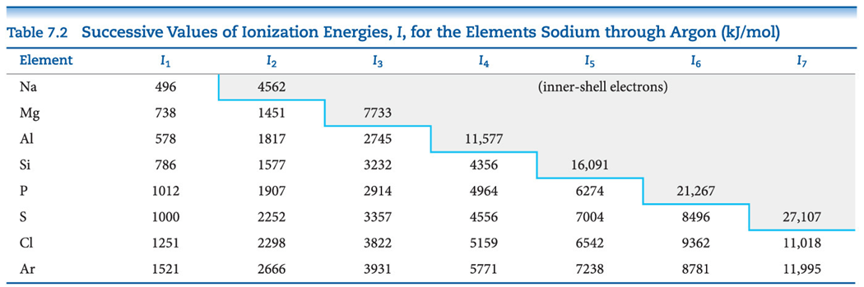
Periodic Trends in First Ionization Energy (I₁)-16  - I₁ generally ____________ across a period.  - I₁ generally ____________ down a group.  - The s- and p-block elements show a ___________ range of values for I₁.  D block-  F block- | Factors that Influence Ionization Energy-17  Smaller atoms have ____________ I values.  I values depend on _______________________ and _____________________ of the electron from the nucleus.  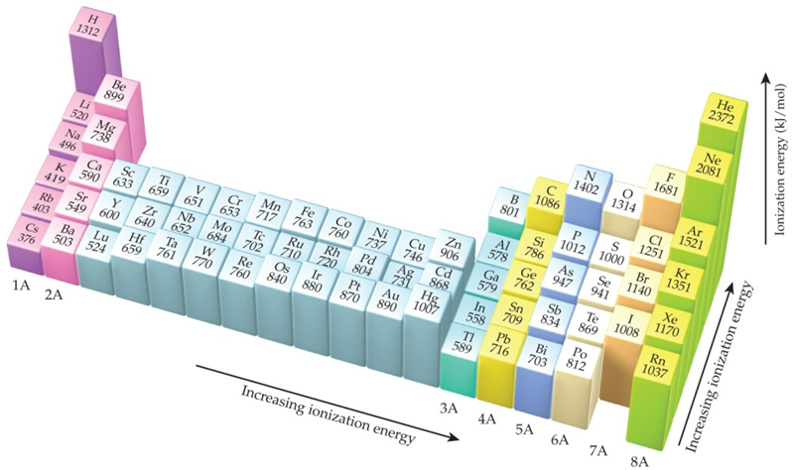
Irregularities in the General Trend-18  The trend is NOT followed when the added valence electron in the next element: | Electron Configurations of Ions-19  Cations: The electrons are lost from the _____________ energy level (____ value)  Example:  Anions: The electron configurations are filled to ________________.  Example:
Electron Affinity-20  Electron affinity is the _____________________ __________________ the addition of an electron to a gaseous atom.  Is it exothermic or endothermic?: ____________  Positive or negative?: ________________  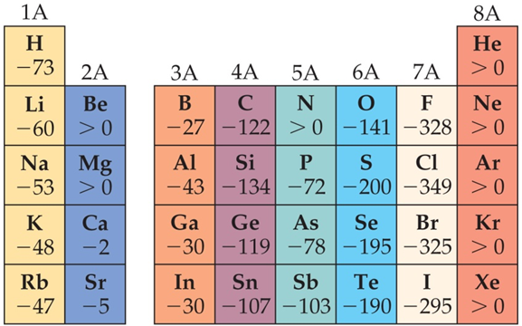 | General Trend in Electron Affinity-21  Not much change in a _____________.  Across a period it generally ________________.  Three notable exceptions:  Note: the electron affinity for many of these elements is ______________ (_______ is unstable)

SUMMARY
______________________________________________________________________________________________________________________________________________________________________________________________________________________________________________________________________________________________________________________________________________________________________________________________________________________________________________________________________________________________________________________________________________________________________________________________________________________________________________________________________________________________________________

