AP CHEMISTRY CHAPTER 8: BASIC CONCEPTS OF CHEMICAL BONDING (Pgs. 298-341)
EQ: _______________________________________________________________________________________________
Questions:
Chemical Bonds-2  Three types of bonds:  -Ionic:  -Covalent:  -Metallic: | Lewis Symbols-3  G.N. Lewis developed a method to denote potential bonding electrons by using one dot for every ____________ __________ around the element ___________.  When forming compounds, atoms tend to _________, __________, or share electrons until they are surrounded by _________ valence electrons (________________).
Ionic Formation-4  Atoms tend to _________ (__________) or _____________ ( ___________) electrons to make them ________________ to the noble gases.  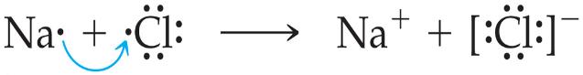 | Energetics of Ionic Bonding-Born-Haber Cycle-5  Many factors affect the energy of ionic bonding.  -Start with the ________________________:  Ex.  -Make ______________ atoms:  Ex.  -Make ions:  Ex.  -Combine the ions: Ex.
Energetics of Ionic Bonding-6  - It takes energy to convert the elements to atoms. (_____________)  - It takes energy to create a cation (_______________).  - Energy is released by making the anion (______________).  - The formation of the solid releases a huge amount of energy (____________).  - This makes the formation of salts from the elements _____________. | Lattice Energy-7  Lattice energy:  The energy associated with electrostatic interactions is governed by ______________ Law.  E_{el}=
Lattice Energy-8  Lattice energy increases with: | Covalent Bonding-9  Atoms ____________ electrons in covalent bonds.  There are several ______________ interactions in these bonds:  For a bond to form, the attraction must be _____________ than the ______________.
Lewis Structures-10  Step 1:  Ex. | Electrons on Lewis Structures-11  Lone Pairs:  Bonding Pairs:
Multiple Bonds-12  Single bonds:  Double bonds:  Triple Bonds:  Example of each: | Polar Covalent Bonds-13  Electrons in _____________ bonds are not always shared _____________.  ___________ pulls harder on the electrons it shares with _____________ than hydrogen does.  This make it so the _____________ end of the molecule has more electron __________ than the ____________ end.
Electronegativity-14  What is electronegativity?  Electronegativity generally _____________ as you go:  -from left to right across a period  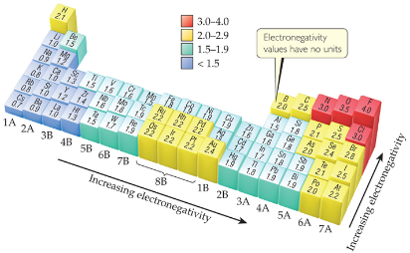  -from the ____________ to the ___________ of a group. | Electronegativity and Polar Covalent Bonds-15  What is it called when atoms share electrons unequally?_________________________  Where do electrons tend to spend more time?: ____________________________________  This results in a __________________________.  It is represented by _________.  This makes the other atom __________________.  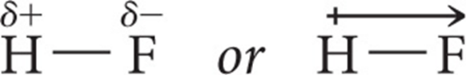  It is represented by ________.
Polar Covalent Bonds-16  The greater the difference in _______________,  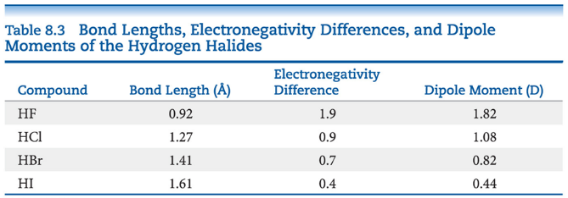  The more ____________ is the bond. | Dipoles-17  A dipole forms when two ____________________  _________________________________________  A dipole moment, ____, is produced by _______ equal but opposite charges, separated by a __________________, ___.  It is calculated by the formula:  It is measured in ____________ (D)
Is a Compound Ionic or Covalent?-18
____________ + ____________ = ionic ____________ + ____________ = covalent
Does not take into account _____________________________________________________
Electronegativity difference can be used, but it still does not take into account the ___________ ____________.
Properties of compounds are often best: __________ melting points mean __________ bonding, for example.

Writing Lewis Structures (Covalent Molecules)-19  - Sum the ____________ electrons from all atoms, taking into account overall charge.  -If it is an anion ________________________  _____________________________________  -If it is a cation ________________________  ____________________________________  Example:  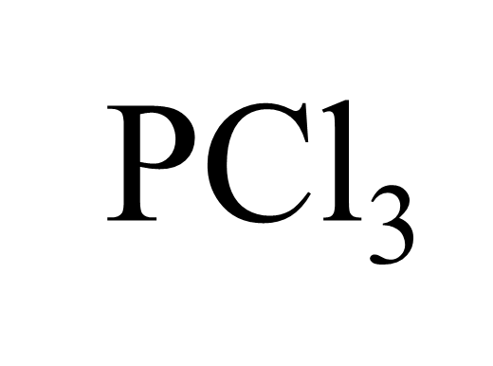  Keep track of the electrons: |  | Writing Lewis Structures-20  - Write the symbols for the atoms, show which atoms are attached to which, and _________________________________ _________________________________  Example Continued:  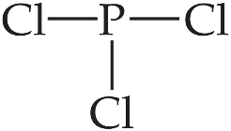  Keep track of the electrons:
Writing Lewis Structures-21  - Complete _________________________  _________________________________  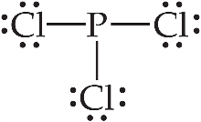  Keep track of the electrons: |  | Writing Lewis Structures-22  - _________________________________  _________________________________  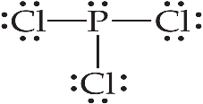  Keep track of the electrons:
Writing Lewis Structures-23
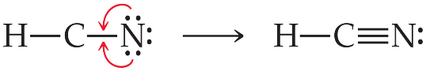
- If there are not enough ______________ to give the central atom an __________, try ____________ bonds.

Writing Lewis Structures-24
- Then assign _______________________.
_________________ is the charge an atom would have if all of the ____________ in a ______________ bond were shared __________.

Formal Charge =
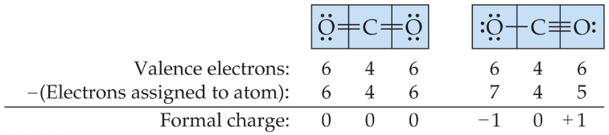

Writing Lewis Structures-25
The dominant Lewis structure:
-Is the one in which atoms have ________________________________________.
-puts a negative formal charge on _______________________________________.

Which is the dominant Lewis structure?
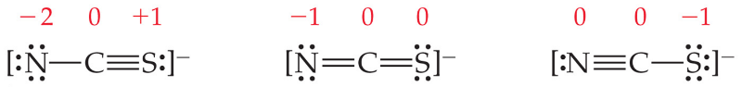

The Best Lewis Structure?-26  Following our rules, this is the Lewis structure we would draw for ozone, _____.  Draw it:  However, it does not agree with what is observed in nature.  What is observed? |  | Resonance-27  One Lewis structure cannot accurately depict a molecule like ozone.  We use multiple structures called ____________ ____________ to describe the molecule.  Draw an example:
Resonance-28  Benzene, _________, has ________ resonance structures.  Draw it:  It is commonly depicted as a _______________  With a circle inside to signify _______________  Electrons in the ring.  Draw it:  Localized:  Delocalized: |  | Exceptions to the Octet Rule-29  There are _________ types of ions or molecules that do not follow the __________ rule.
Odd Number of Electrons-30  These are relatively _____________ and usually quite _____________ and ________________.  There are __________ and ________________  With an odd number of ___________________.  Example: |  | Fewer Than Eight Electrons-31  Where can elements be found that make stable compounds with fewer than eight electrons?:  Example:  Why?:
Fewer Than Eight Electrons-32  If filling the octet of the ______________ atom results in a ____________ charge on the central atom and a ____________ charge on the more _______________________ outer atom, don’t fill the octet of the central atom.  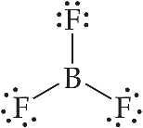 |  | More Than Eight Electrons-33  When an element is in period _______ or below in the PT, it can use ____________ to make _________ than four bonds.  Example:
Covalent Bond Strength-34  How is the strength of a bond determined?:  What do we call this? _____________________  Example: |  | Average Bond Enthalpies-35  Average bond enthalpies are positive because _________________________________________.  These are _______________ over many different compounds; not every bond in nature for a pair of atoms has exactly the same __________________.  C—H = Cl—Cl = H—Cl =
Using Bond Enthalpies to Estimate Enthalpy of Reaction-36  One way to estimate ΔH for a reaction is to use the ______________________ of bonds broken and the new bonds formed.  _______________ is added to break bonds, and _______________ when making bonds.  In other words:  ΔH_{rxn} = Σ(bond enthalpies of all bonds broken) − Σ(bond enthalpies of all bonds formed). |  | Example-37  From the figure on the last slide:  CH₄(g) + Cl₂(g) ⎯⎯→ CH₃Cl(g) + HCl(g)  Solve:
Answer-38 |  | Bond Enthalpy and Bond Length-39  An average ____________________ can be measured for different bond types.  As the number of bonds between two atoms _________________, the bond length ___________________.

SUMMARY
______________________________________________________________________________________________________________________________________________________________________________________________________________________________________________________________________________________________________________________________________________________________________________________________________________________________________________________________________________________________________________________________________________________________________________________________________________________________________________________________________________________________________________

